

Laboratory Testing of the [name] Stove
One ISO 19867-1 test at Aprovecho Research Center on [single_test_date]. One test can be used during the iterative development process to estimate the effect of changing a single variable in an evolving stove prototype. More repetitions increase confidence. These tests do not constitute an ISO 19867 test series to be used for any official purpose.

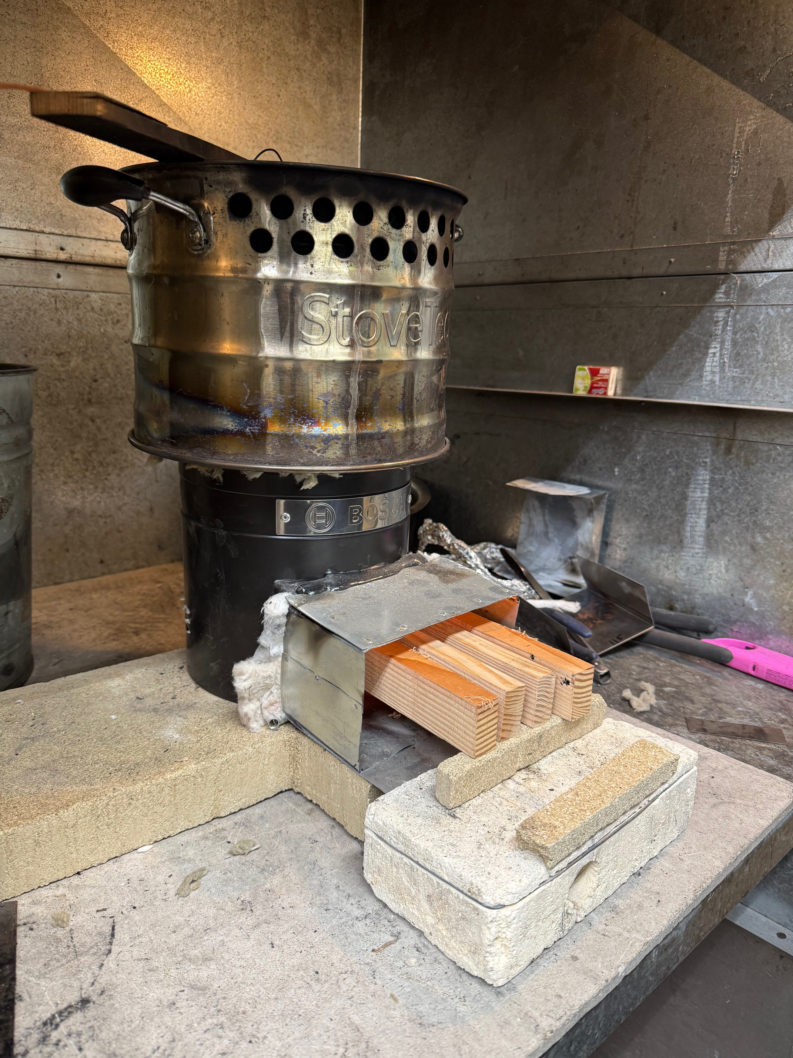
Upgraded [stove_name] prototype, tested with the [pot_name]
With funding from the Osprey Foundation, the [stove_name] was [updated_or_developed] at Aprovecho Research Center in [Month_of_Year]. One ISO 19867 test is summarized in this report. A standard laboratory test was carried out using the ARC Laboratory Emissions Monitoring System (LEMS) and the ISO 19867-1:2018 Water Heating Test at three power levels. The primary ISO metrics are provided and are shown with the ISO 19867-3:2018 Voluntary Tiers of Performance. The stove is rated Tier [tier_eff_wo_char] for thermal efficiency without char and Tier [tier_eff_w_char] with char, Tier [tier_pm] for PM_{2.5} emissions, and Tier [tier_co] for CO emissions. Safety and durability tests were not performed.

Summary of results
The stove boiled five liters of water in a [pot_name] in [time_to_boil_hp] minutes at high power, [time_to_boil_mp] minutes at medium power and [time_to_boil_lp] minutes at low power.

Description
FULL STOVE DESCRIPTION GOES HERE, INCLUDE ALL RELEVANT MEASUREMENTS AND DETAILS OF CONSTRUCTION. EXAMPLE BELOW.
The upgraded [stove_name] Stove is a [continuously_or_batch] fed stove. The metal stove body is [stove_height] cm tall and [stove_diameter] cm in diameter [, with an insulated bottom or none or etc]. [Refractory ceramic cloth or other or none] insulation fills the space around a [xx] cm in diameter [metal, ceramic, etc] combustion chamber. [combustion chamber details if any go here. i.e. the following] There is a [xx] cm tall by [xx] cm deep firebrick in the back of the combustion chamber to encourage only 8 cm of fuel stick tips to burn in the combustion chamber. A [description of] stovetop with 6mm pot supports is used. The fuel door is [x] cm wide x [x] cm tall. The door is surrounded with a [x] cm wide by [x] cm deep sheet metal shroud (as shown above). A solid sheet metal stick support [x] cm long by [x] cm wide by [x] cm tall extends into the combustion chamber leaving an open space of 8 cm to encourage only the tips of the sticks to burn.

Methods
The test protocols are described in ISO 19867-1:2018, which is a laboratory test for cookstoves to be evaluated with performance metrics such as thermal efficiency and emissions released per unit energy delivered to the cooking pot. Test results do not predict field performance. Laboratory testing has been shown to significantly underestimate emissions and overestimate thermal efficiency.

Stove and Operating Procedures
To operate the stove at different power levels, more sticks were added for higher firepower and less sticks for lower firepower. For high power, [x] sticks were used. For medium power, [x] sticks were burned. For low power, [x] sticks were combusted. [x] kg of fuel (wet basis) was burned during high power, [x] kg for medium power, and [x] kg at low power. The high, medium and low powers were monitored by the operator, adjusting the feed rate to maintain the power levels. The combustion process was managed carefully attempting to achieve the various power levels while maintaining high combustion efficiency.

Starting Sequence
To light the fire, [40 grams of charcoal, soaked in ethyl alcohol,] was placed in the bottom of the combustion chamber. Immediately after ignition, the desired fuel load was placed on the stick support extending above the burning [charcoal]. A space was created between each stick to allow air to enter the flame.

Fuel
The stove was operated [with pieces of Douglas Fir] with dimensions of [2.2] cm wide x [4] cm tall x [23 cm long, and a moisture content of 12 %. The Higher Heating Value of the Douglas Fir was estimated to be 20634 J/g and the Higher Heating Value of the charcoal was estimated to be 32500 J/g.
The Lower Heating Value of both the wood and the charcoal is based on the method specified in the ISO protocol, which depends on the chemical composition of the fuel. The percentage of H, O, and N of the wood was assumed to be 6.3 percentage H, 40.5 percentage O, and 0.1 percentage N, respectively. For charcoal the percentages were assumed to be 3.1 percentage H, 11.3 percentage O, and 0.2 percentage N. The resulting Lower Heating Value of the wood was 19,314 J/g, and for the charcoal, it was 31,300 J/g.
The Effective Heating Value of the wood was estimated to be 16703.16 J/g using the calculation specified in the ISO protocol which is dependent on moisture content.

The Cooking Vessel
The cook pot is a [stainless steel] [seven] liter [SSM SuperPot], which is [24] cm in diameter with an attached skirt. The skirt fits tightly on top of the stove top and has a [12] mm channel gap up the sides of the pot and [0.75] constant cross sectional vents near the top of the pot.

Voluntary Performance Targets (from ISO/TR 19876-3)
Table 1 – Voluntary performance targets – default valuesª

 | Tier^{b} | Thermal efficiency  (%) | Emissions |  | Safety (score)^{c} | Durability (score)^{d}
 |  |  | CO  (g/MJ_{d}) | PM_{2,5} (mg/MJ_{d})
Better  performance | 5 | ≥50 | ≤3,0 | ≤5 | ≥95 | <10
 | 4 | ≥40 | ≤4,4 | ≤62 | ≥86 | <15
 | 3 | ≥30 | ≤7,2 | ≤218 | ≥77 | <20
 | 2 | ≥20 | ≤11,5 | ≤481 | ≥68 | <25
 | 1 | ≥10 | ≤18,3 | ≤1030 | ≥60 | <35
 | 0 | <10 | >18,3 | >1030 | <60 | >35
ªFor non-default values, see Clause 6.
^{b}The tier level for each performance metric shall be reported separately. See example in Table 2.
^{c}Safety protocols (Clause 7 in ISO 19867-1 [1]) cover solid-fuel stoves and solar cookers only.
^{d} Durability protocols (Clause 8 in ISO 19867-1 [1]) evaluate common material failures in biomass cookstoves. The protocol is not comprehensive of all failures that might be found in the field, nor are the tests found in the durability protocol applicable for all cookstoves. Instead the durability protocol seeks to cover the most prevalent durability concerns found across a range of cookstove technologies and construction materials.

Default Emission Factors (from ISO/TR 19876-3)

The default emission factors for PM_{2,5} (as shown in Table 1 in 5.2) are presented in Table 7 with additional details on the corresponding relative risks, emission concentration, emission rate, and the percentage of homes meeting each tier level.

Table 7 – Default emission factors, rates, equivalent concentrations
and % homes meeting specified criteria, for PM_{2,5}

 | Tier | RR | mg/MJ_{d} | Normalized Emission Rate (mg/min) | µg/m³ | Percentage of homes meeting the tier level
Better  performance | 5 | 1,0 | ≤5 | ≤0,2 | ≤10 | ≥90%
 | 4 | ≤1,5 | ≤62 | ≤2,7 | ≤50 | ≥50%
 | 3 | ≤2,5 | ≤218 | ≤9,5 | ≤170 | ≥50%
 | 2 | ≤3,0 | ≤481 | ≤21 | ≤400 | ≥50%
 | 1 | ≤3,15 | ≤1031 | ≤45 | ≤800 | ≥50%
 | 0 | >3,15 | >1031 | >45 | >800 | <50%
NOTE Tier reporting is based on emission factor, and normalized emission rate is a derived property. Measured emission rates from laboratory testing are not used to determine tiers for reporting.

